Name:____________________________________________ Date:________________ Period: _______

Honors Physics Quiz #1: Conversions, 1D Motion, (30 Points) Mr. Werman
Multiple Choice: Place the letter of the correct answer choice on the blank space provided. (2 Points Each)
_____ 1. The distance traveled by an object is always _____________________________ its displacement.
- Greater than or equal to
- Less than or equal to
- Greater than
- Less than

_____ 2. If an object moves with a negative average velocity over a certain time interval, what can be said about its displacement?
a. The displacement will be in the positive direction.
b. The displacement will be in the negative direction.
c. The displacement will be zero.
d. The displacement is unrelated to the velocity.

_____ 3. Which of the following lab procedural statements BEST follows the OAIM framework?
a. Measure the height of the ball and release it from rest.
b. Release the car from the top of the ramp and use a stopwatch to measure the time to the bottom.
c. Measure the height for each trial with a meterstick.
d. Slide the disc along the surface of the ground and record the distance traveled for three separate trials.
_____ 4. What is the main difference between speed and velocity?
a. Speed is a vector quantity, while velocity is scalar
b. Speed includes direction, while velocity does not
c. Velocity includes direction, while speed does not
d. Speed and velocity are identical quantities

_____ 5. Which scenario describes the greatest amount of displacement?
a. A cyclist travels 25 km west.
b. A racecar completes 15 laps around a 2 km long track.
c. A boat sails 20 km east
d. A car drives 10 km east then turns around and drives another 20 km west.

6. Convert 426 $\frac{dip}{tack^{4}}$ to $\frac{pop}{rip^{4}}$ (Note: 1 dip = 6 dop, 1 dop = 8 pop, and 3 tack = 10 rip) (5 Points)

For Questions 7 & 8, the following table and graph represent data collected for a toy car during an in-class lab.
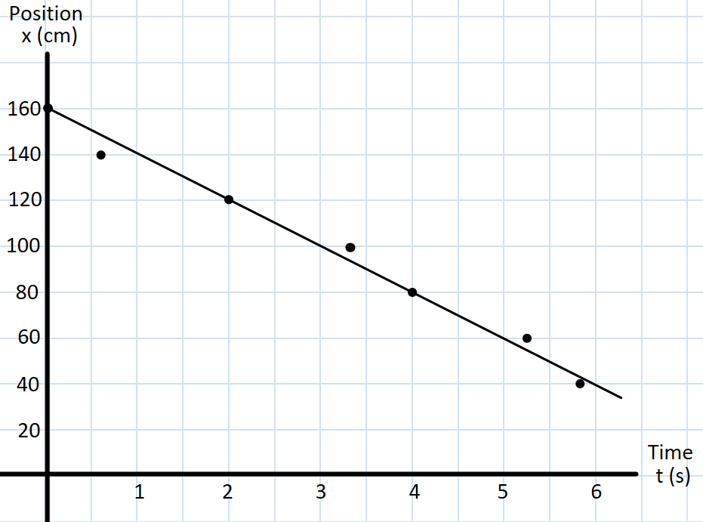

7. What is the speed of the car? (Show how you calculate your value & include proper units) (3 Points)

8. Write an equation to model the car’s motion based on the line of best fit from the graph above. (2 Points)

9. The Blue car starts at the +3.20 m mark and finishes at the -1.40 m mark over a period of 8.2s. What was its average velocity? Sketch the motion of the car on a Position vs Time graph (label the axes). (5 Points)

10. Coach Ansel takes his players through a conditioning drill in practice. Starting under the basket at the endline, the player sprints 47 feet to midcourt in 2.5 s, then backpedals 28 ft with a speed of 6 ft/s to a cone at the free throw line, before sprinting to the far endline at a speed of 15 ft/s.
a) What is the player’s total time for the drill? (3 Points)

b) Sketch the Position vs Time and Velocity vs Time Graphs for the player’s motion: (2 Points)

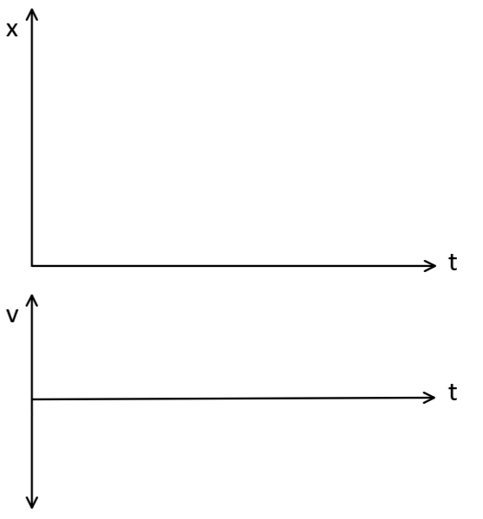

Bonus (2 points)
A father and son are driving separate cars to Penn State for move-in day. The father drives conservatively with a constant velocity of 55 mph, while the son sets a quicker pace of 62 mph. The son arrives at campus 18 minutes ahead of his father. How far was the trip?

17. A 7.25 kg bowling ball traveling with constant speed hits the pins at the end of an 18.3 m long bowling lane. The bowler hears the sound of the ball hitting the pins 3.50 s after the ball is released from his hands. How much momentum does the ball have when it strikes the pins? (Note: the speed of sound is 343 m/s)
(10 Points)

16. The Flower Car starts at the -2 m mark driving with a velocity of +18 cm/s. At the same time, the Army Car is 5 m away on a path for a head-on collision traveling at 3.5 times the Flower Car’s speed. If both cars remain at constant speed, where will they collide? (10 Points)

18. The motion of a child pedaling a BigWheel tricycle (combined mass of 18 kg) is shown in the graph below. A second child riding a motorized PowerWheel truck starts is 9 meters away heading in the opposite direction at half the speed. They collide head-on and come to rest. (10 Points)
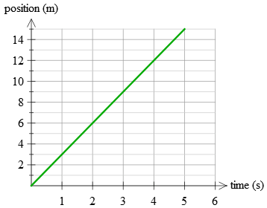
a) Sketch the motion of the PowerWheel truck on the graph.
b) What is the mass of the PowerWheel truck (with rider)

